1:M Cube Validations:

Cube 1 and 2:

ldb.f_rita_application_legal_entity_c and ldb.f_rita_application_data_category_c permission.

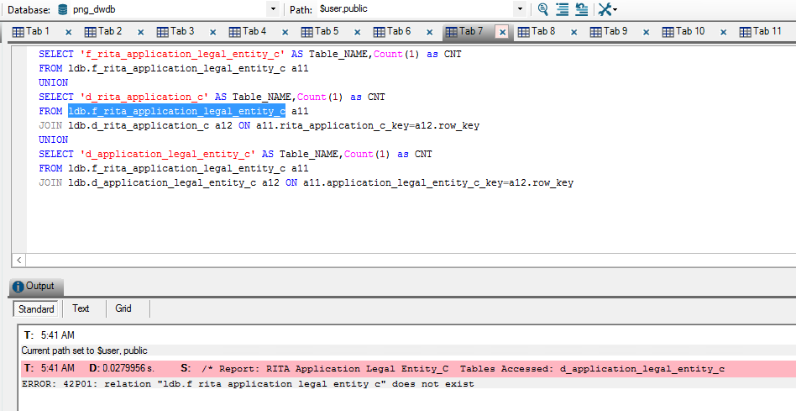

Cube 3: F_rita_application_site

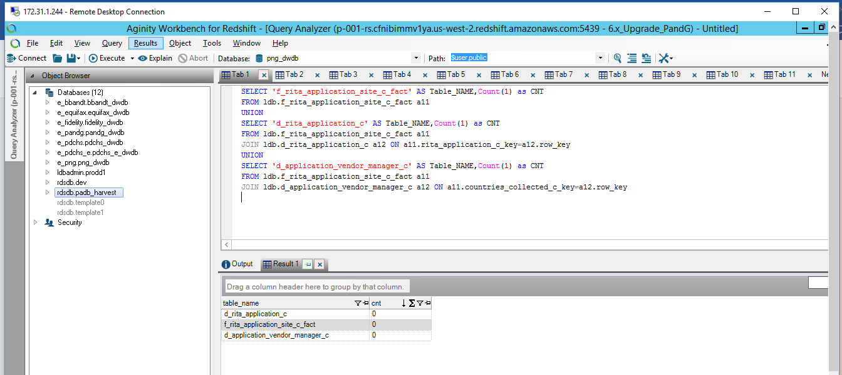

Cube 4: f_rita_application_data_elements_c_fact.

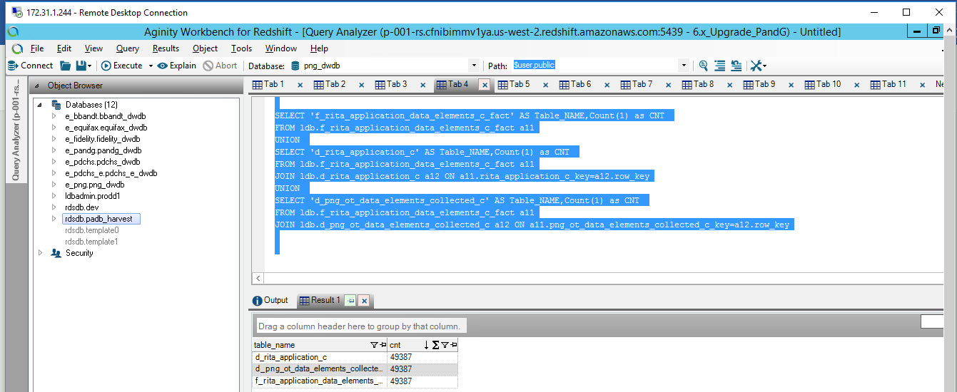

Cube 5: f_rita_application_governance_supplier_c_fact

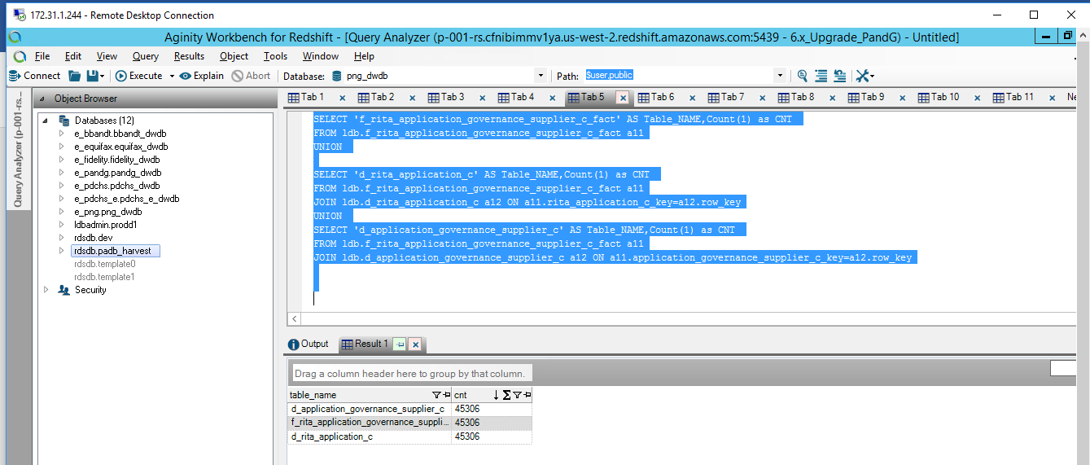

Cube 6 : f_rita_application_implementation_supplier_c_fact

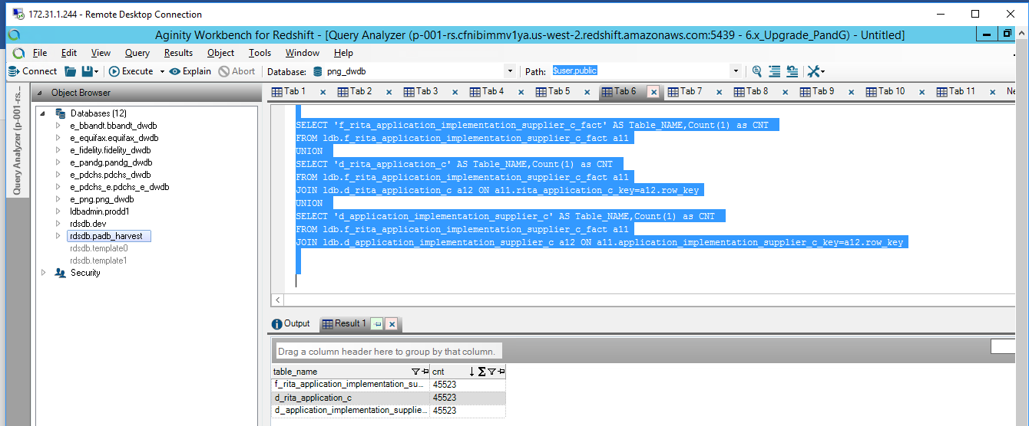

Cube 7: f_rita_application_service_operations_supplier_c_fact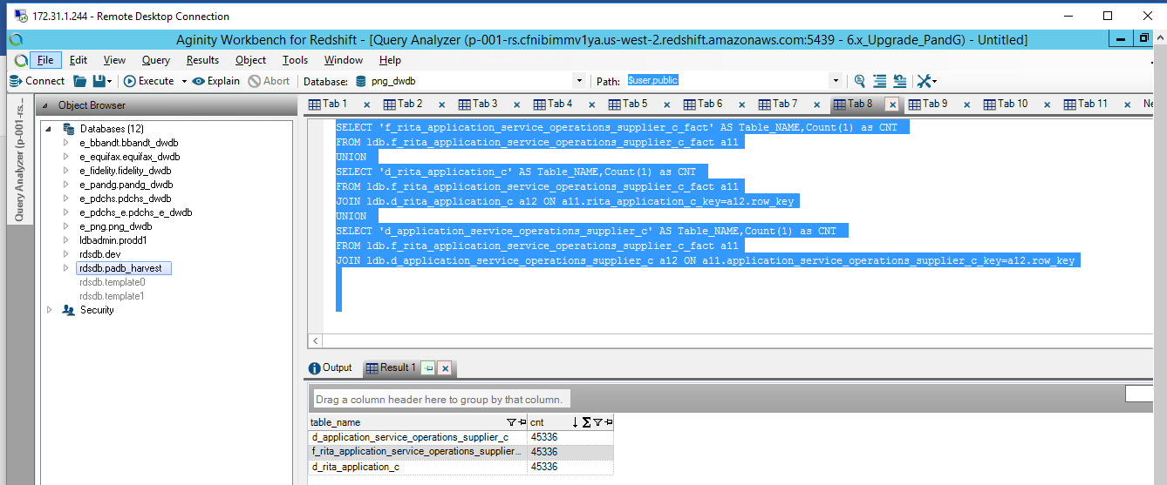

Cube 8: f_rita_application_software_supplier_c_fact

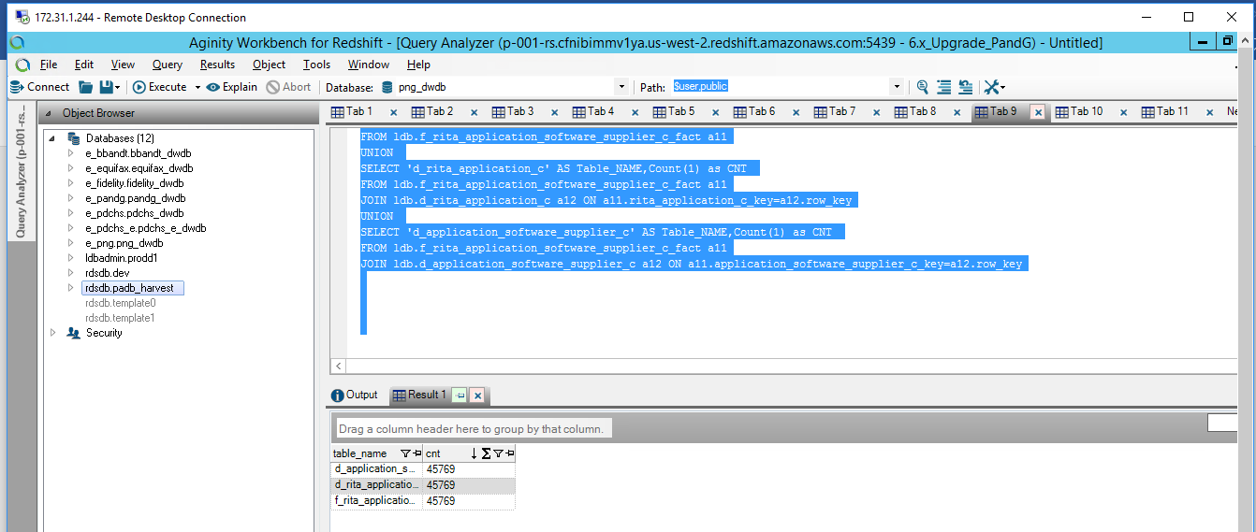

Cube 9: f_rita_application_technology_supplier_c_fact

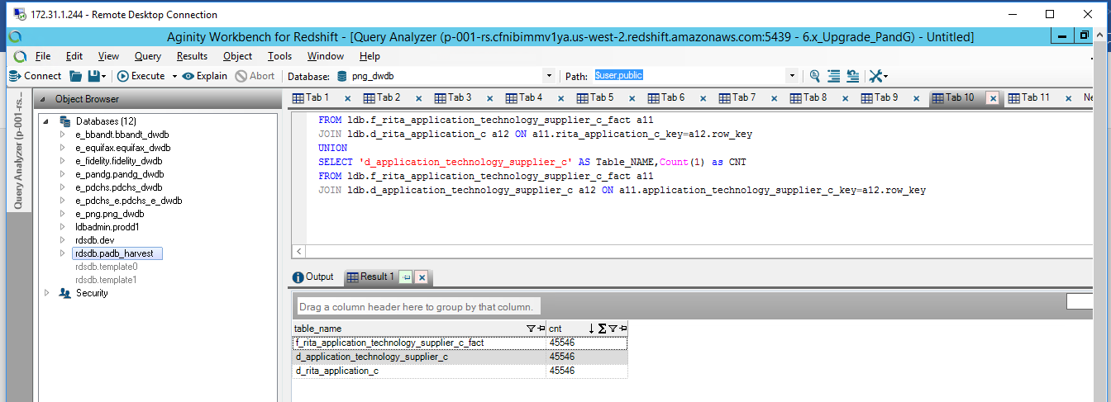

Cube 10: f_rita_application_vendor_manager_c_fact

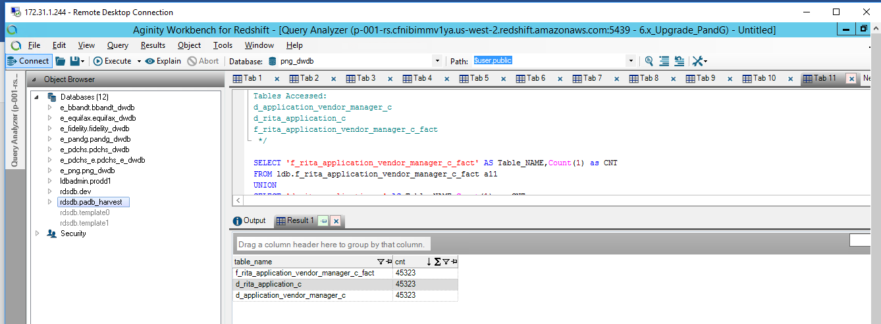

Cube 10: